Family Tree Worksheet

Directions: This is an example of how to organize your family tree as you gather information about your family’s history. Write the names of your relatives next to how they’re related to you. Write their professions down next to their names. Substitute yourself for “Jane.”

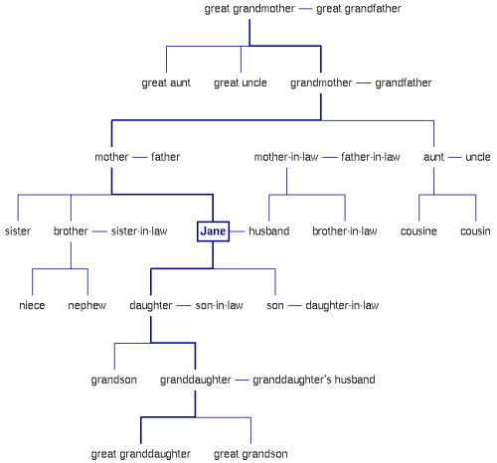

Did anyone have to change their profession when they entered the United States? (only for ancestors who immigrated to the U.S.A.) ___________________________________________________________________________________________________________________________________________________________________________________________________________________________________________________________________________________________________________________________________________________________________________________________________________________________________________

What are some of the adjustments/changes your relatives had to make because they immigrated? _____________________________________________________________________________________________________________________________________________________________________________________________________________________________________________________________________________________________________________________________________________________________________________________________________________________________________________________________________________________________________________________________________________________________________

What big changes do your parents/grandparents remember taking place as they grew up? Ask about entertainment, chores and tools used to do those chores, for example: _____________________________________________________________________________________________________________________________________________________________________________________________________________________________________________________________________________________________________________________________________________________________________________________________________________________________________________________________________________________________________________________________________________________________________

Use more paper if necessary! Be detailed! Learn your family’s folklore!

